**Week 2 Module 3.3 Assignment**

Juan Macias Vasquez

Bellevue University

CSD340-H323 Web Development with HTML and CSS (2261-DD)

**Adam Bailey**

August 22th, 2025

**Module 3.3 Assignment GitHub**

**GitHub Repository Link**

<https://github.com/Juan551School/csd-340>

**Link to GitHub pages landing page**

<https://juan551school.github.io/csd-340/>

**Project 3.3 Page**

<https://juan551school.github.io/csd-340/module-3/assignment-3.3/Macias_Mod3_3.html>

**HTML Code:**

<!-- Juan Carlos Macias Vasquez

Week 2 Module 3.3 Assignment

CSD340-H323 Web Development with HTML and CSS(2261-DD)

August 22th, 2025

HTML Code for Assignment

-->

<!DOCTYPE html>

<html lang="en">

<head>

<meta charset="UTF-8">

<title>CSD 340 Web Development with HTML and CSS</title>

<link rel="stylesheet" href="Macias_Mod3_3.css">

</head>

<body>

<div id="container">

<h1>Assignment 3.3: Build a Web Page Exercise - Part 3</h1>

<div class="flex-container">

<!-- Left Box -->

<div class="left-div">

<h3>Top 10 Favorite Books</h3>

<ol>

<li>Dragon Balle</li>

<li>Lord of the Rings </li>

<li>Code Geass</li>

<li>The Hobbit</li>

<li>The Hitchhiker's Guide to the Galaxyt</li>

<li>Tokyo Ghoul</li>

<li>Demon Slayer</li>

<li>Dune (have only read the first book)</li>

<li>Game of Thrones</li>

<li>The Hunger Games (only read the first three)</li>

</ol>

</div>

<!-- Right Box -->

<div class="right-div">

<h3>5 Things I've Learned Since the Course Started</h3>

<ul>

<li>How the .css files connect to the Html file for proper aliment and size</li>

<li>How to connect the links on an html file to others to make pages</li>

<li>How to set the color in the webpages and make things pop </li>

<li>How to improve websites by making it easier for eh user to get used to it from the 100 Things book</li>

<li>Learning what the read me file in GitHub was and how to add things to it and change its font</li>

</ul>

</div>

</div>

<!-- Bottom link -->

<div class="bottom-link">

<a href="../../index.html">back to Landing Page</a><!-- Had to use "C:\csd\csd-340\index.html" on my computer -->

</div>

</div>

</body>

</html>

**CSS Code:**

/* Juan Carlos Macias Vasquez

Week Module 3.3 Assignment

CSD340-H323 Web Development with HTML and CSS(2261-DD)

August 22th, 2025

This CSS file styles the HTML document for the assignment.

*/

/* Center the main title */

h1 {

text-align: center;

}

/* Flexbox for side-by-side layout */

.flex-container {

display: flex;

justify-content: space-between;

}

/* Shared box styles */

.left-div, .right-div {

width: 45%;

padding: 10px;

font-weight: 300;

}

/* h3 titles */

h3 {

font-weight: 500;

}

/* Books */

.left-div {

border: 1px solid red;

border-radius: 15px;

list-style-position: inside;

}

/* Things learned */

.right-div {

border: 1px dashed red;

border-radius: 15px;

list-style-position: inside;

}

.right-div ul {

list-style-type: upper-roman;

padding-left: 20px;

}

/* Bottom link */

.bottom-link {

width: 100%;

margin-top: 60%;

margin-bottom: 20px;

float: right;

}

/* Hover effect for links */

a:hover {

text-decoration: underline;

}

**Screen Shots of Web Page**

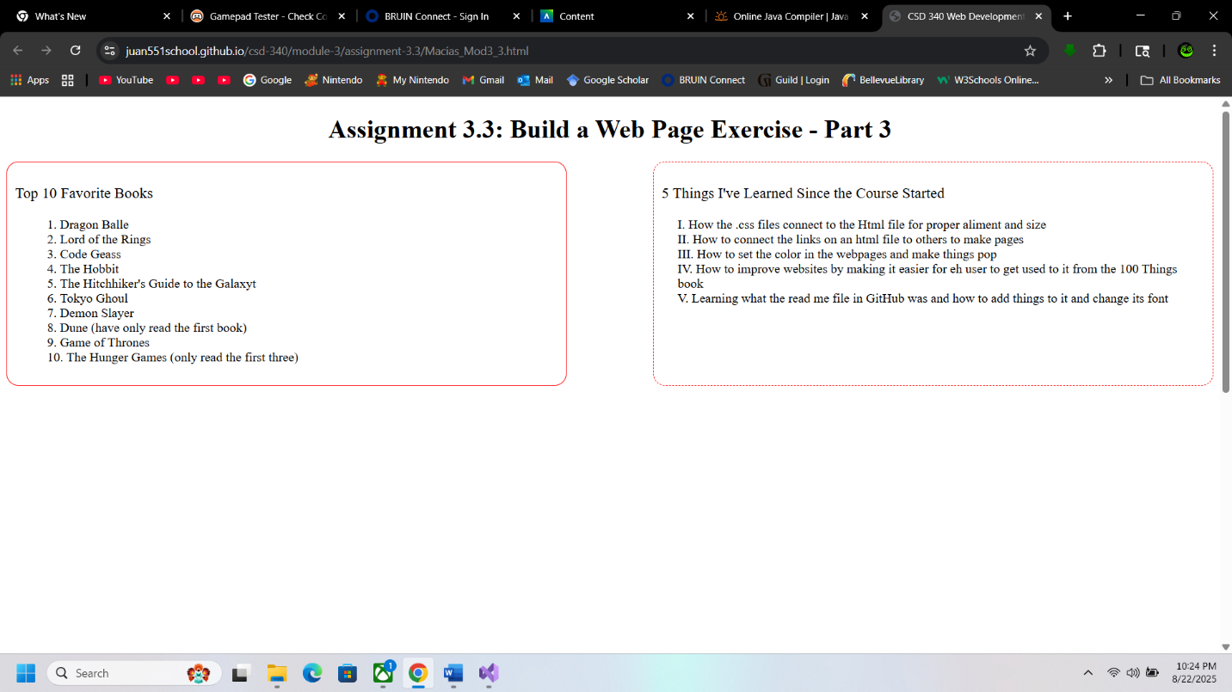

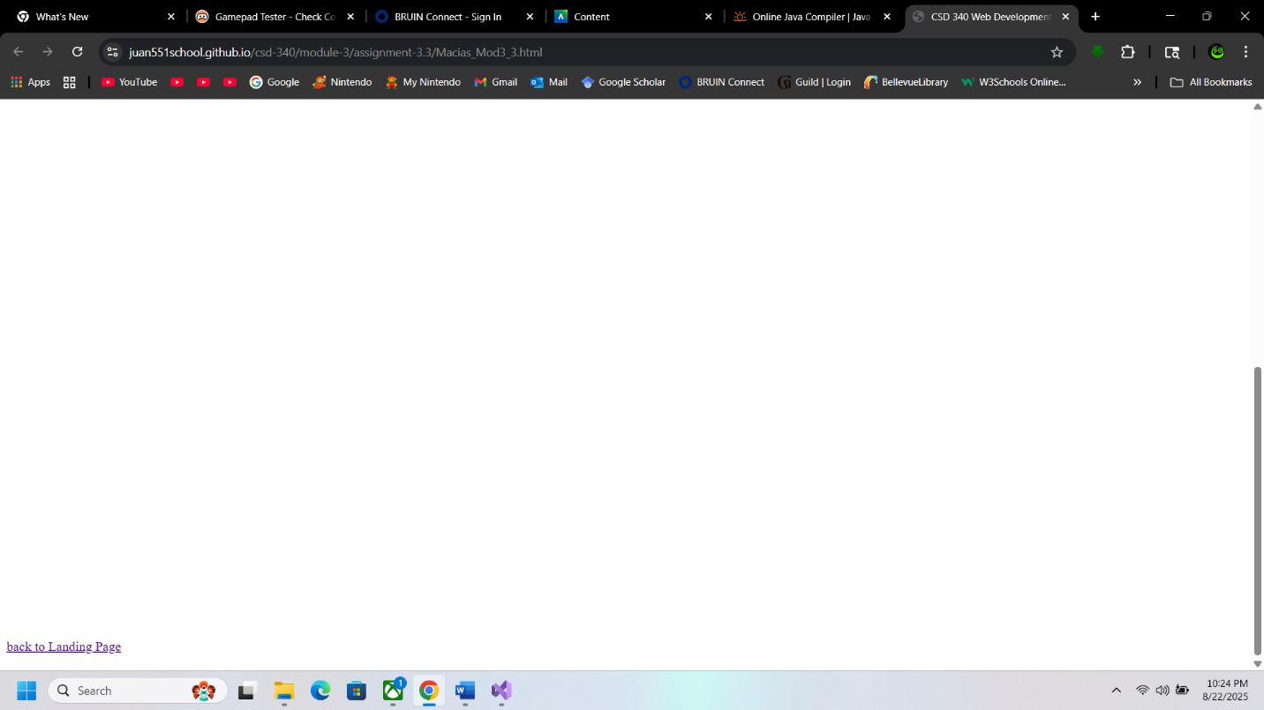

**Validation Pictures**

**HTML**

I couldn’t get rid of the errors after changing the path to the other pages but they did work

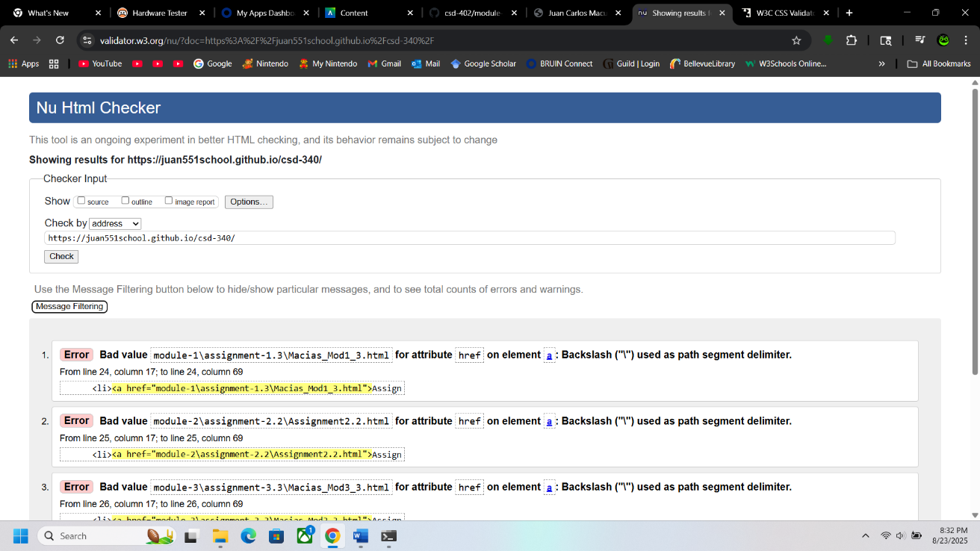

**CSS check**

NO Errors

